Nama : Nayla Dwi Ramadhani

Nim : 09010182327002

Kelas : Mi 3A

Matkul : Pratikum Jaringan Komputer

**PRATIKUM JARINGAN KOMPUTER**

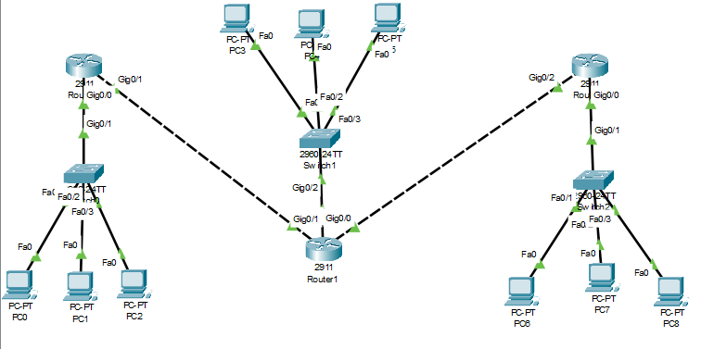

Router 1

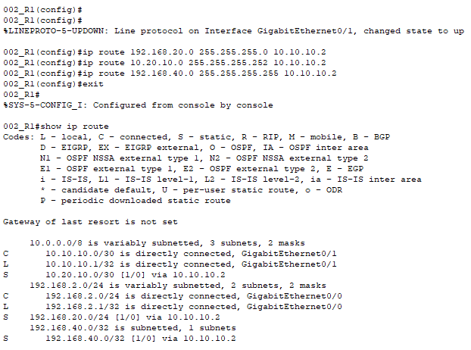

Router 2

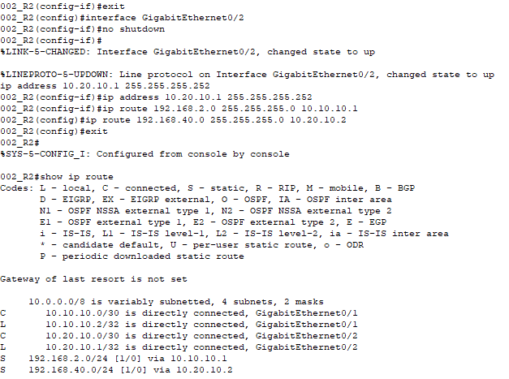

Router 3

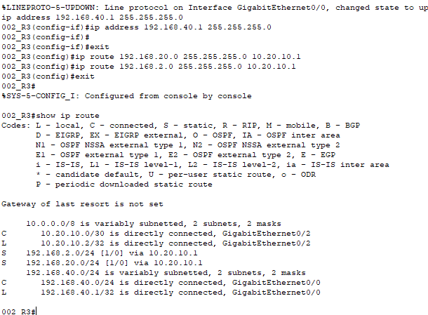

**Tes koneksi icmp**

|  |  |  |  |  |
| --- | --- | --- | --- | --- |
| No | Sumber | Tujuan | Hasil | |
| Ya | Tidak |
| 1 | PC 1 | Pc 2 | Ya | - |
| Pc 3 | Ya | - |
| Pc 4 | Ya | - |
| Pc 5 | Ya | - |
| Pc 6 | Ya | - |
| Pc 7 | Ya | - |
| Pc 8 | Ya | - |
| Pc 9 | Ya | - |

|  |  |  |  |  |
| --- | --- | --- | --- | --- |
| No | Sumber | Tujuan | Hasil | |
| Ya | Tidak |
| 1 | PC 4 | Pc 1 | Ya | - |
| Pc 2 | Ya | - |
| Pc 3 | Ya | - |
| Pc 5 | Ya | - |
| Pc 6 | Ya | - |
| Pc 7 | Ya | - |
| Pc 8 | Ya | - |
| Pc 9 | Ya | - |

|  |  |  |  |  |
| --- | --- | --- | --- | --- |
| No | Sumber | Tujuan | Hasil | |
| Ya | Tidak |
| 1 | PC 7 | Pc 1 | Ya | - |
| Pc 2 | Ya | - |
| Pc 3 | Ya | - |
| Pc 4 | Ya | - |
| Pc 5 | Ya | - |
| Pc 6 | Ya | - |
| Pc 8 | Ya | - |
| Pc 9 | Ya | - |

Pc 1 -> pc 5

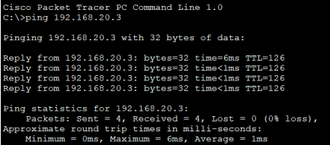

Pc 1 -> pc 7

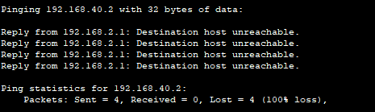

Pc 4 -> pc 2

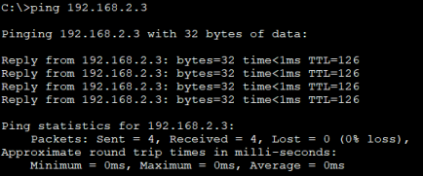

Pc 4 -> pc 8

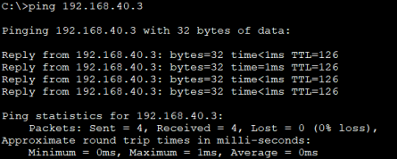

Pc 7 -> pc 9

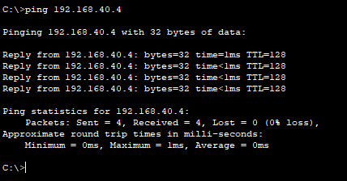

Pc 7 -> pc 3

